Introduction & Problem Statement
Canada was one of the first countries in the world to release a national AI strategy back in 2017. It is home to some of the most influential AI researchers in history, including Geoffrey Hinton and Yoshua Bengio, and its universities consistently produce top-tier machine learning talent. On the surface, Canada looks like an AI leader.
But being early does not mean staying ahead. Over the past several years, the global AI race has intensified dramatically. The United States and China are pouring hundreds of billions of dollars into GPU clusters, data centers, and chip manufacturing. The European Union has passed comprehensive AI legislation. Smaller countries like Singapore and the UAE are climbing the rankings by investing aggressively in infrastructure and governance. Meanwhile, Canada's advantages in research and talent have not been matched by equivalent investments in the physical and regulatory foundations that modern AI systems require.
This raises a straightforward question: where does Canada actually stand in AI competitiveness today, and what should the federal government prioritize to close the gaps that matter most?
To answer this, we take a mixed-methods approach. We use quantitative analysis — including clustering, regression, and gap analysis on the 2024 Tortoise/Stanford AI Index dataset covering 36 countries — to measure Canada's position, identify its closest peer countries, and pinpoint the specific areas where it leads and where it falls behind. We also complement those findings with a qualitative review of 17 policy documents, expert reports, and government strategies from around the world, and use those insights to develop three actionable policy recommendations targeting Canada's most critical weaknesses.

Part 1: Evaluating Canada’s Current AI Competitiveness

1.1 Data Collection
The quantitative analysis in this study draws on the Global AI Vibrancy Tool dataset, developed by Stanford University’s Institute for Human-Centred AI (HAI)[1]. The dataset spans 66 countries across eight annual snapshots (2017–2024) and contains 230 indicators organized into raw values, per-capita adjustments, and min-max normalized scores (scaled 0–100 within each year). We restrict our analysis to the 36 “core” countries with consistent longitudinal coverage and use the normalized indicators as our primary features.
To complement the quantitative data, we collected qualitative evidence including national AI strategy documents (OECD, UK, US, Singapore, Germany, Malaysia, and the Stanford HAI AI Index Report 2025); online policy reports and publications focused on Canada’s AI compute gap; and social media transcripts covering Canadian enterprise AI adoption and infrastructure investment. These qualitative sources were processed through a two-stage LLM summarization pipeline using the OpenAI API.

1.2 Feature Engineering and Selection
From the 230 available indicators, we curated a set of 26 features organized into five thematic pillars: Research & Innovation, Investment & Commercialization (private investment, newly funded companies), Talent (AI skills penetration, talent concentration), Policy & Governance (AI-related bills passed, legislative AI mentions), and Infrastructure (supercomputers, compute capacity, internet speed). Each pillar includes both absolute and per-capita normalized variants to capture a country’s total scale as well as its per-person intensity. The feature correlation matrix (Appendix A, Figure A1) confirms that features cluster strongly within pillars while exhibiting low cross-pillar correlation, supporting the thematic grouping.

1.3 Analytical Approach
Our analysis proceeds in three stages. First, all 26 features are standardized and reduced via Principal Component Analysis (PCA) to 9 components, retaining 92.5% of total variance. This shared PCA representation is used consistently across all subsequent methods. Second, we apply K-Nearest Neighbors (KNN) and hierarchical clustering to identify Canada’s closest peer countries and to segment the 36 nations into AI development tiers. Importantly, KNN is used here as an unsupervised nearest-neighbor search rather than a classification algorithm—we query the 5 countries closest to Canada in PCA space to establish a peer group for benchmarking. Third, we perform Lasso regression and gap analysis to quantify which dimensions drive overall AI competitiveness and where Canada’s specific strengths and weaknesses lie.

1.4 Peer Identification and Clustering
KNN identifies Canada’s five nearest peers as the Netherlands (distance = 1.44), Germany (1.56), Malaysia (1.77), the United Arab Emirates (1.83), and France (1.97), measured by Euclidean distance in PCA space (Appendix A, Figure A2). This peer group spans three regions, reflecting that AI competitiveness cross-cuts geography.
To validate this peer grouping, we apply both K-Means and Agglomerative (Ward linkage) clustering, evaluating cluster counts from k = 2 to 10 using silhouette scores (Appendix A, Figure A3). Both methods converge on k = 3 as optimal (silhouette = 0.619), producing three tiers: the United States and China as a dominant pair, Luxembourg as a per-capita outlier, and the remaining 33 countries—including Canada and all five of its KNN peers—in a broad middle tier. While the k = 3 result correctly identifies US–China dominance, it offers limited differentiation within the middle tier.
The hierarchical dendrogram (Figure 1) provides richer insight. Canada clusters most closely with Malaysia, Poland, Germany, the Netherlands, and the United Arab Emirates—closely mirroring the KNN peer set. This convergence between two independent methods strengthens confidence in the identified peer group.
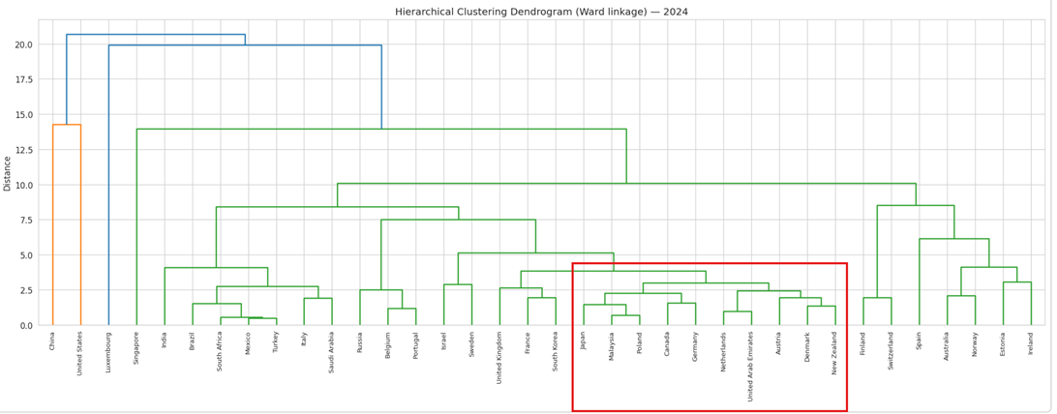
Figure 1: Hierarchical clustering dendrogram (Ward linkage) of 36 countries on 2024 AI competitiveness features. The red box highlights the sub-cluster containing Canada and its nearest peers. See Appendix A Figure A4 for a larger illustration.

1.5 Regression and Feature Importance
To identify which per-capita factors most strongly predict overall AI competitiveness, we construct a composite score (mean of absolute normalized features) and fit a Lasso regression using PCA components as predictors. Under leave-one-out cross-validation, the Lasso model achieves R² = 0.878 (MAE = 1.92), substantially outperforming Random Forest (R² = 0.598) and Gradient Boosting (R² = 0.728). Lasso’s built-in feature selection retains 7 of 13 per-capita features, with private investment per capita, patent grants per capita, and research submissions per capita emerging as the strongest positive predictors. While informative for understanding what drives AI competitiveness broadly, regression results did not directly inform our country-specific gap analysis and are included primarily for methodological completeness.

1.6 Gap Analysis—Canada’s Strengths and Weaknesses
The central finding of our quantitative analysis emerges from comparing Canada against the mean of its five KNN peers on each thematic pillar (Figure 2). Canada lags its peers in two dimensions: Infrastructure (gap = −5.2 normalized points), driven by compute capacity (ranked 27th/36), per-capita compute (29th), and internet speed (15th); and Policy & Governance (gap = −1.8), driven primarily by the fact that Canada has passed zero AI-related bills on a three-year moving average (ranked 26th). Conversely, Canada leads in Talent (+4.7), with the highest relative AI skills penetration among its peers, Research & Innovation (+2.9), supported by strong per-capita publication and citation rates, and Investment & Commercialization (+2.0).
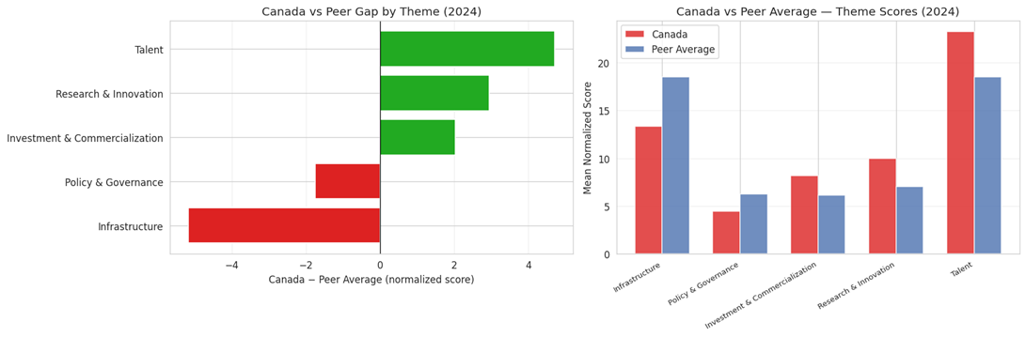
Figure 2: Canada vs. peer average across five AI competitiveness themes (2024). Left: gap scores (negative indicates Canada lags). Right: absolute theme scores.
We also compare individual features of Canada, peer countries, and three outlier countries across the years. The line charts (Appendix A, Figure A5) confirm the conclusion that Canada is leading in talent and research, while lagging in infrastructure and computing capacity.

1.7 Qualitative Synthesis
Cross-source analysis of the qualitative sources corroborates and contextualizes the quantitative findings. Multiple sources—including the OECD National AI Strategy Overview, the C.D. Howe Institute report on data supply chains [2], and the Dais policy brief “Can Canada Compute?” [3]—identify Canada’s lack of sovereign AI compute capacity as a critical gap. The UK AI Opportunities Action Plan and Singapore’s National AI Strategy 2.0 provide peer benchmarks: the UK is establishing AI Growth Zones for accelerated data center permitting, while Singapore’s government co-invests directly in AI compute infrastructure. On the policy dimension, sources note that while Canada was an early mover with its 2017 Pan-Canadian AI Strategy, it has not followed through with binding AI legislation, unlike the EU (AI Act) and peer countries that have passed targeted governance frameworks. Qualitative sources also confirm Canada’s talent strength but raise concerns about brain drain to better-resourced US ecosystems—a risk that further underscores the infrastructure gap.

1.8 Summary and Intro to Recommendations
Our analysis reveals a structural imbalance in Canada’s AI ecosystem: strong talent and research output coexist with weak infrastructure and policy frameworks. This creates a risk that Canadian AI innovations are developed domestically but commercialized and scaled abroad due to insufficient compute resources and regulatory clarity. Based on these findings—supported by both quantitative gap analysis and qualitative cross-source synthesis—we propose three infrastructure-focused recommendations in the following sections: (1) Redirect federal AI infrastructure funding to provinces with more available power capacity (2) developing the critical mineral supply chain to reduce dependence on foreign semiconductor manufacturing, and (3) enacting AI sovereignty legislation to close the governance gap.
Part 2: Proposal for Canada’s AI Strategy (and Steps)

2.1 Canada's AI Hardware Mineral Strategy
Why Minerals are Important in the AI Race. The global race for supremacy in artificial intelligence has entered a new and profoundly physical phase. While the first decade of the artificial intelligence revolution was characterized by breakthroughs in algorithmic efficiency and the curation of massive datasets, the current era is defined by the hardware substrate upon which these models are trained and deployed. The strategic center of gravity has shifted from software to the silicon, and more specifically, to the complex array of critical minerals required to manufacture advanced semiconductors and sustain hyperscale data centers.

Mineral | Primary Technical Function | Impact on AI Performance
Silicon | Fundamental substrate for integrated circuits | Bedrock for all microchip manufacturing and scaling
Boron | P-type dopant for silicon lattice | Enables control of current flow in logic and memory circuits
Phosphorus | N-type dopant for silicon lattice | Essential for creating alternating junctions in transistors
Gallium | Compound semiconductors (GaN, GaAs) | Increases efficiency and heat resistance in high-power chips
Germanium | High-speed transistors and fiber optics | Enhances electron mobility and reduces signal loss in networking
Indium | Photodetectors and transceivers | Facilitates rapid data transmission in data center optical networks
Cobalt | Interconnect metallization | Prevents electromigration in advanced semiconductor nodes

China's Dominance and Export Restrictions. The current global landscape reveals a stark imbalance in the control of AI-related minerals. China maintains an overwhelming dominance across the entire value chain, from extraction to refining. It produces approximately 98.7% of the world's primary gallium, 95% of its magnesium, 82.7% of its tungsten, and nearly 70% of its rare earth elements. [4] More critically, China's share of refined mineral supply is even higher, controlling over 85% of refined rare earths and 85% of synthetic graphite. [5] The risks associated with this concentration were realized in late 2024 when China implemented bans on the export of certain critical materials, including gallium, in response to U.S. trade restrictions. [6] These non-market policies and practices have led to a structural mismatch in the market, where supply is subject to political whims rather than economic demand. For the United States and its allies, this dependence creates a situation where the next wave of AI innovation could be throttled by a lack of access to the physical materials required for hardware expansion.

Canada’s Mineral Reserves. Canada holds world-class deposits of all the minerals currently identified as critical for the AI boom. Key areas of mineral production are: Ontario and Quebec have nickel, cobalt, and lithium; Newfoundland and Labrador, Northwest Territories, and Nunavut produce copper, rare earth minerals, and other strategic minerals. Canada has 15 million tonnes of rare earths in resources, which is one of the world’s highest concentrations in the North. Canada is the #4 global producer of platinum, a mineral crucial for catalytic processes and semiconductor plating. [7] From the point of view of global supply chains, Canada’s current output of critical minerals is still limited in scale, accounting for less than 5% of the total amount produced worldwide for important minerals like cobalt and lithium. Estimates suggest that Canada could account for an average of 14 percent of the global supply across six key critical minerals—cobalt, nickel, lithium, copper, graphite, and rare earths—by 2040 if planned projects proceed at full capacity. [8]

Current Situation. A historical weakness in Canada's mining sector has been the "mine-and-ship" model, where raw materials are exported for refining—often to China—before being sold back as high-value components. [9] The Canadian Critical Minerals Strategy is actively working to close this gap by investing in midstream refining and processing. As of March 2025, Canada has 31 active critical mineral processing facilities and 28 new processing projects in the advanced stages of development. [10] This shift is essential for retaining value within the domestic economy and ensuring that the final products used in AI hardware are produced responsibly.

2.1.1 Recommendation
The objective is to transition Canada from a net exporter of raw ores to a refiner and manufacturer of high-purity materials to capture domestic value. The current practice of exporting minerals for refining abroad, only to import them back as finished components, represents a significant strategic vulnerability and a lost economic opportunity. To bypass the 10-to-15-year lead time for traditional large-scale refineries, Canada must prioritize modular, relocatable processing. First, Canada will move away from China’s massive mixer-settler tanks to column-based systems like Ucore’s RapidSX platform. This technology runs approximately three times faster than conventional systems and has a significantly smaller physical footprint. Second, to avoid the lengthy environmental reviews required for new "greenfield" mines, Canada should prioritize secondary supply chains through modular waste processing. Modular units can be deployed at historic mine sites to extract rare earth elements and battery metals from tailings, coal ash, and industrial waste.

In Year 1, high-priority modular projects will be referred to the Major Projects Office (MPO) for "National Interest" status to begin the accelerated 2-year permitting track. The $2 billion Critical Minerals Sovereign Fund (CMSF), launching in Spring 2026, will be utilized to sign government-backed offtake agreements for initial modular outputs. This provides the revenue certainty required for project financing. In Year 2, commission the Rio Tinto gallium pilot plant in Saguenay and Ucore’s NdPr separation facility in Kingston. These modular units will demonstrate the ability to produce high-purity oxides without traditional mixer-settler infrastructure. In Year 3, transition from pilots to full-scale commercial recovery of graphite and rare earths from tailings and e-waste, specifically targeting projects like Green Graphite Technologies in Kingston. The estimated cost is $2.5 billion (includes the $2B Critical Minerals Sovereign Fund and $443M for innovative processing and stockpiling). The responsible ministry is Natural Resources Canada (NRCan) and Innovation, Science and Economic Development Canada (ISED), supported by the Major Projects Office (MPO). The primary metric is the achievement of a domestic production capacity of 400 metric tonnes of high-purity neodymium-praseodymium (NdPr) metal annually by 2028. This volume represents a significant erosion of China's midstream monopoly and provides enough material to anchor an independent North American supply chain for the permanent magnets required in AI robotics and defense systems.

2.2 Policy

2.3 Infrastructure

References
[1] Stanford University HAI, “Global AI Vibrancy Tool,” 2024. [Online]. Available: https://aiindex.stanford.edu/vibrancy/
[2] C.D. Howe Institute, “The Missing Pillar of Canada’s AI Strategy: Data Supply Chains,” Feb. 2026.
[3] The Dais, Toronto Metropolitan University, “Can Canada Compute? Policy Options to Close Canada’s AI Compute Gap,” Mar. 2024.
[4]https://elements.visualcapitalist.com/how-much-control-china-has-over-the-worlds-critical-minerals/
[5] https://elements.visualcapitalist.com/china-still-dominates-critical-mineral-refining-in-2030/
[6] https://www.gravel2gavel.com/ai-critical-materials/
[7] https://www.investcanada.ca/industries/critical-minerals
[8] https://www.rbc.com/en/thought-leadership/climate-action-institute/energy-reports/mine-refine-bridging-canadas-critical-minerals-capital-gap-2/
[9] https://thefutureeconomy.ca/op-eds/canadas-critical-mineral-moment/
[10] https://www.canada.ca/en/campaign/critical-minerals-in-canada/canadas-critical-minerals-strategy/canadas-critical-minerals-strategy-progress-update.html
[11] https://www.mintz.com/insights-center/viewpoints/2151/2023-11-03-us-canada-critical-mineral-ev-battery-and-semiconductor
[12] https://www.rbc.com/en/thought-leadership/the-trade-hub/the-new-great-game-how-the-race-for-critical-minerals-is-shaping-tech-supremacy/
[13] https://www.riotinto.com/en/news/releases/2026/rio-tinto-advances-gallium-metal-rd-project-in-partnership-with-the-government-of-canada
[14] https://www.canada.ca/en/campaign/critical-minerals-in-canada/critical-minerals-an-opportunity-for-canada/semiconductors.html

Appendix A: Data Analysis
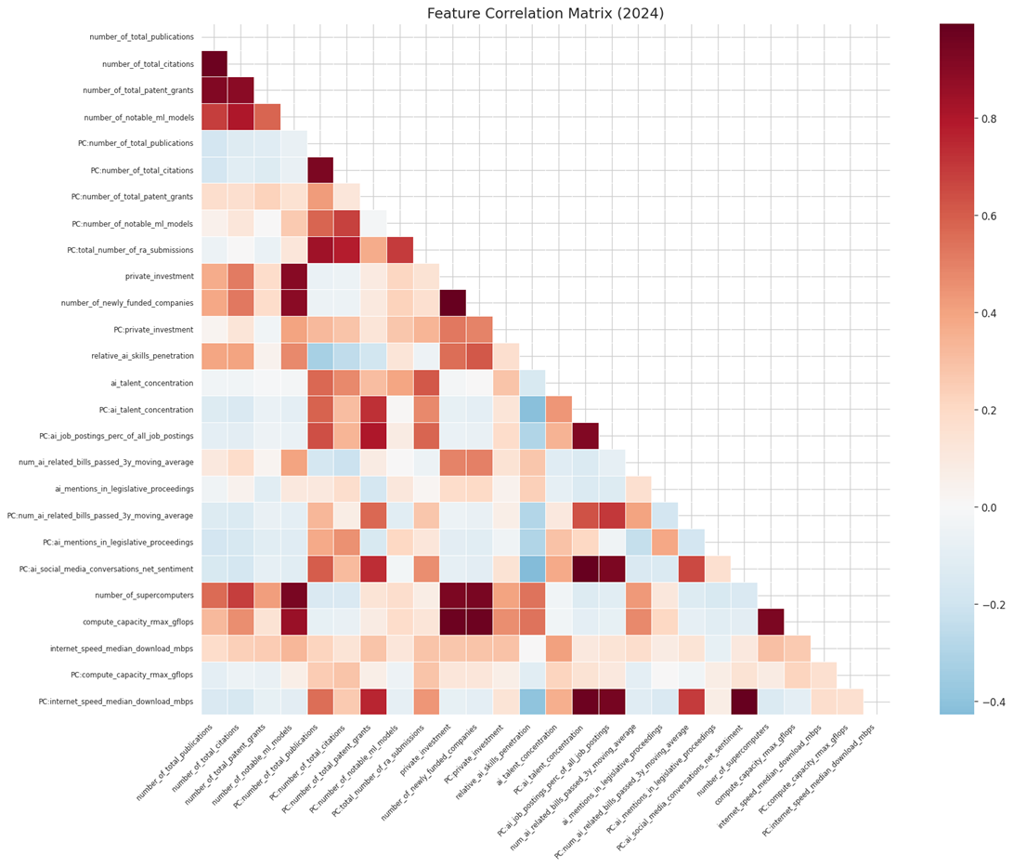
Figure A1: Feature Correlation Matrix. This matrix list in the axis features that are used in data analysis. The heatmap confirms the set of pillars, for example, the number of newly funded companies is high correlated with private investment.

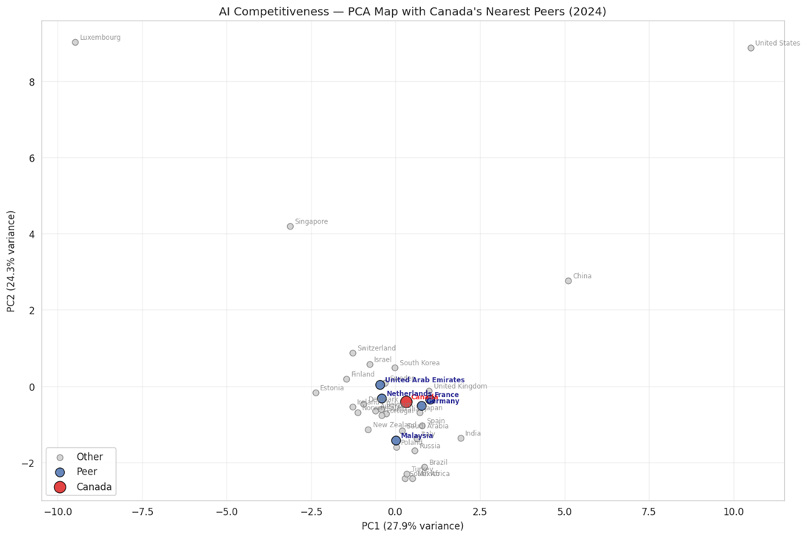
Figure A2: AI competitiveness of Canada and nearest peers in PCA space.

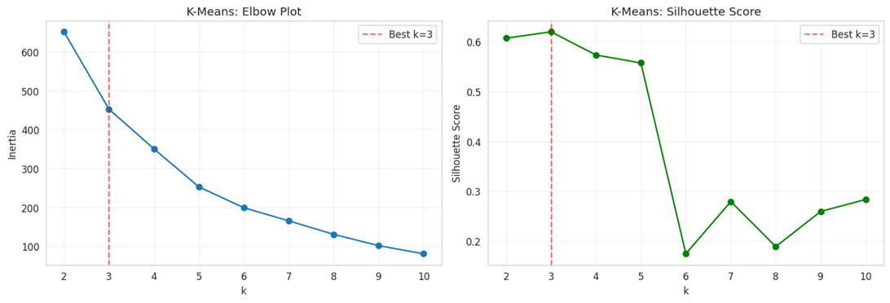
Figure A3: Elbow test and silhouette scores of K-Means experiments.
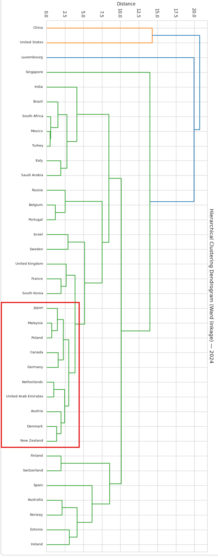
Figure A4: Hierarchical clustering dendrogram.
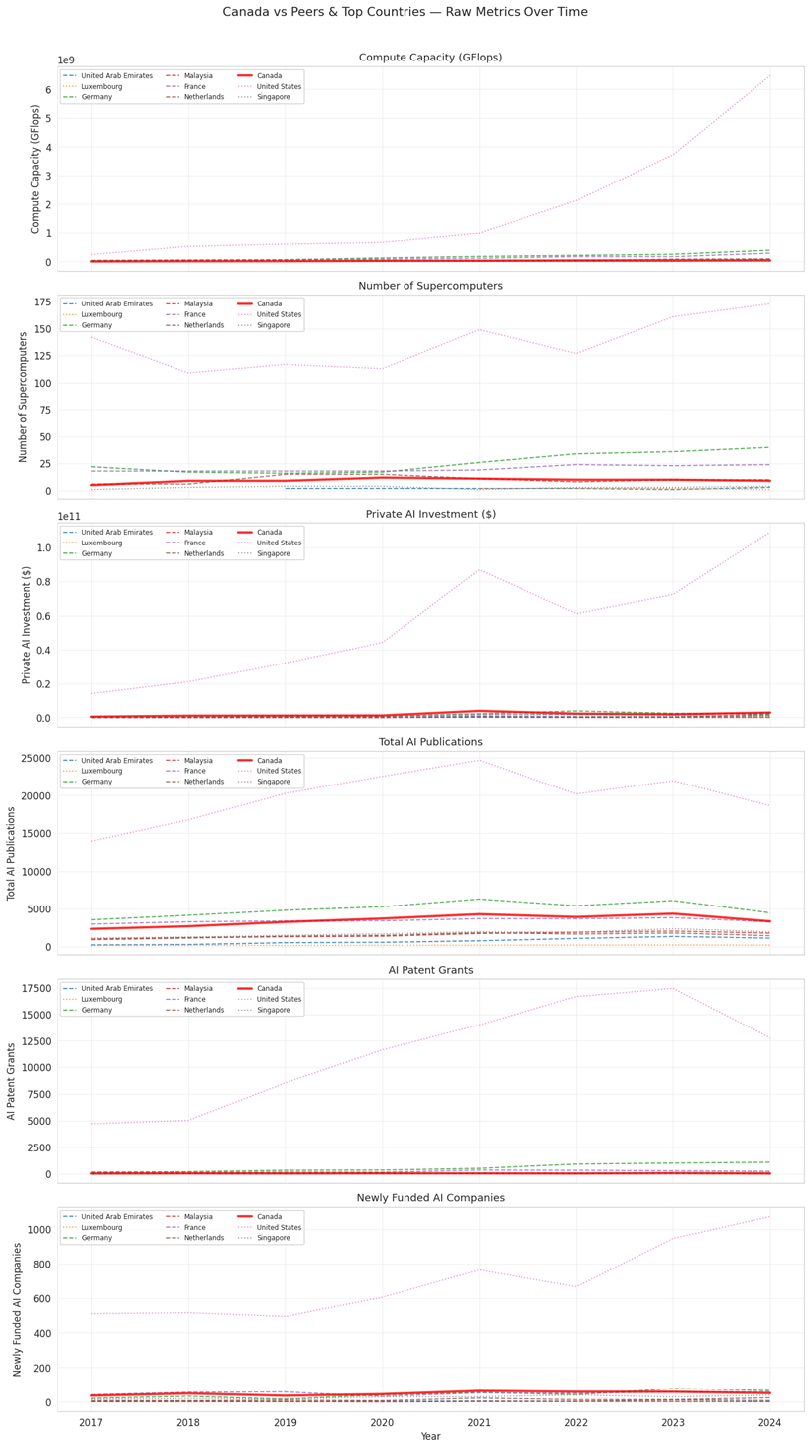
Figure A5: Raw metric comparison between Canada and target countries.

Part 2: Proposal (3 recommendations) (1 page per recommendation)
- Infra: power supply, data center (Steven)
- Mineral (Jason, John)
  - Price, storage
- Policy (Stella, Queena)
  - Policy that stops external investment? Stops mining?
  - Privacy and security concerns

Things to consider
- Why are they important
- How is other countries doing
- What do other countries do to improve

Part 3: Practical Step to Implement each recommendation (1 page per recommendation)
Each recommendation must include: estimated cost, implementation timeline (1-3 years), responsible ministry or agency, and one specific metric for measuring success. Expected improvement over time

Part 4: Chatbot (1 page)

The LinkedIn AI Talent Index
https://economicgraph.linkedin.com/content/dam/me/economicgraph/en-us/PDF/li-ai-talent-index.pdf

*Stanford HAI Index Vibration Tool*
https://hai.stanford.edu/ai-index/global-vibrancy-tool
https://drive.google.com/drive/folders/1AxxxL9-AsaeMdDKtTNHCR1KqEJTsHCod

National AI Policy/Strategy

- OECD National AI Strategy Overview
https://www.oecd.org/content/dam/oecd/en/publications/reports/2021/08/an-overview-of-national-ai-strategies-and-policies_913b6e4b/c05140d9-en.pdf

- UK AI Opportunities Action Plan
https://assets.publishing.service.gov.uk/media/67851771f0528401055d2329/ai_opportunities_action_plan.pdf

- Singapore National AI Strategy
https://file.go.gov.sg/nais2023.pdf

- Singapore Smart Nation 2.0
https://file.go.gov.sg/nais2023.pdf

- Canadian Sovereign AI Compute Strategy
https://ised-isde.canada.ca/site/ised/en/canadian-sovereign-ai-compute-strategy
https://ised-isde.canada.ca/site/ised/en/ai-sovereign-compute-infrastructure-program
https://ised-isde.canada.ca/site/ised/en/canadian-sovereign-ai-compute-strategy/ai-compute-challenge

- America’s AI Action Plan
https://www.whitehouse.gov/wp-content/uploads/2025/07/Americas-AI-Action-Plan.pdf

AI Preparedness Index (AIPI)

Tortoise Media AI data

Readiness Assessment Methodology | Global AI Ethics and Governance Observatory

Government AI Readiness Index 2025 - Oxford Insights

Talent Index: https://www.insead.edu/global-talent-competitiveness-index

Innovation Index: https://www.wipo.int/en/web/global-innovation-index/2025/innovation-clusters

AI Investment：
https://etcjournal.com/2025/08/15/top-10-countries-in-ai-rd-aug-2025/
Analysis of Countries in Terms of Artificial Intelligence Technologies: PROMETHEE and GAIA Method Approach

